|  |  |
| --- | --- |
|  | **FPT ACADEMY INTERNATIONAL**  **FPT – APTECH COMPUTER EDUCATION** |

**Centre Name: ACE-HCMC-2-FPT.**

**Address: 590 Cach Mang Thang 8, District 3, Ho Chi Minh City, Viet Nam.**

Online Auction

**Design Document**

|  |  |  |
| --- | --- | --- |
| **Supervisor:** | Mr. TRAN PHUOC SINH | |
| **Semester:** | 3 | |
| **Batch No:** | T1.2008.A0 | |
| **Group No:** | 3 | |
| **Order:** | **Full name** | **Roll No.** |
| 1. | PHAN PHUC THINH | Student1275061 |
| 2. | NGUYEN THI MINH THU | Student1273010 |
| 3. | TRAN HOANG QUOC TAI | Student1273014 |
| 4. | VO THI KIM DUNG | Student1275249 |

**Month**: December **Year**: 2022

# Work Process

1. **User (Front-end)**

User can use system for:

* Before login:
* View Auction
* View Auction Details
* Search auction by name
* View Seller information
* Register
* Login
* After login:
* View Profile
* Edit information Account
* View My Auction
* Participate to the auction
* Checkout
* Review for Seller
* Report
* Create ,Edit,Delete Auction
* Logout

1. **Admin (Back-end)**

Admin must login first to manage system

* Change password
* Logout
* User manage:
* View users list
* Add admin
* Lock User
* Category manage:
* View categorys list
* Add new category
* Update category
* Delete category
* Auction manage:
* View Auctions list
* Detail Auction
* Approve Auction
* Lock Auction
* News manage:
* View News list
* Add new News
* Update News
* Delete News
* Rating manage:
* View Ratings list
* Report manage:
* View Report list

# GUI DESIGN

## Homepage

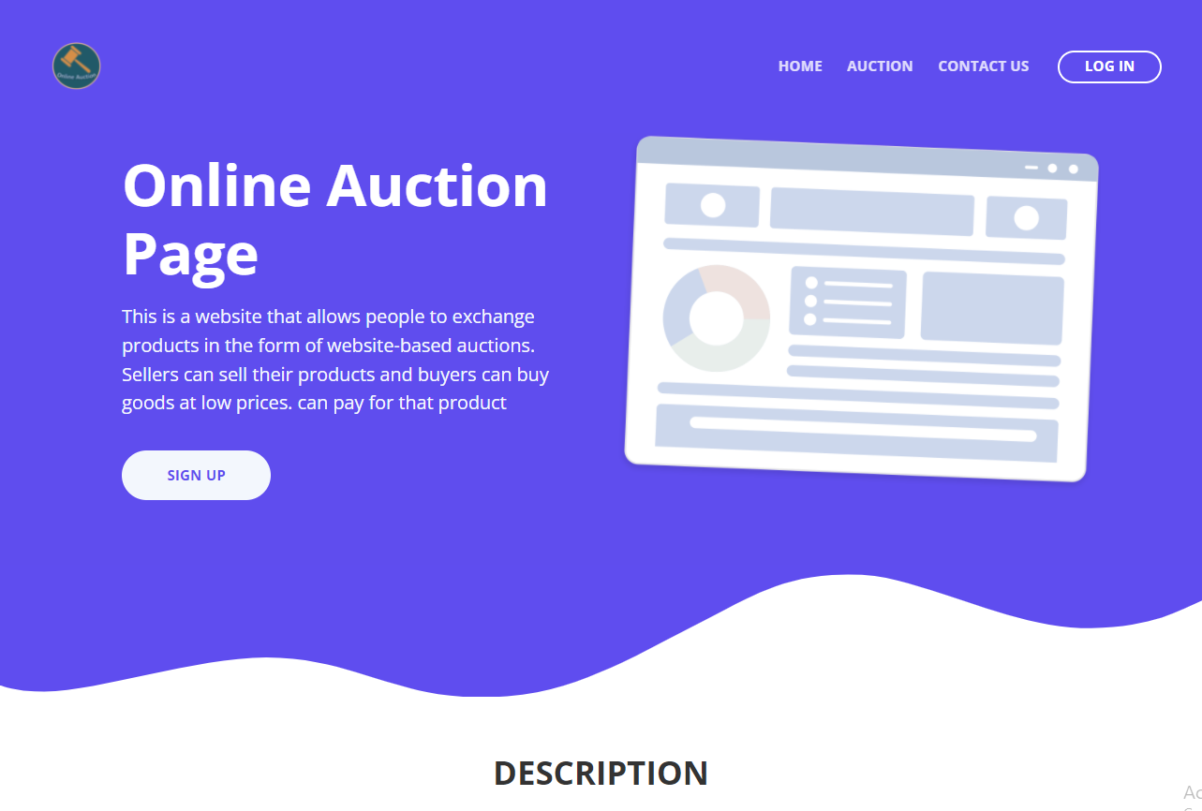 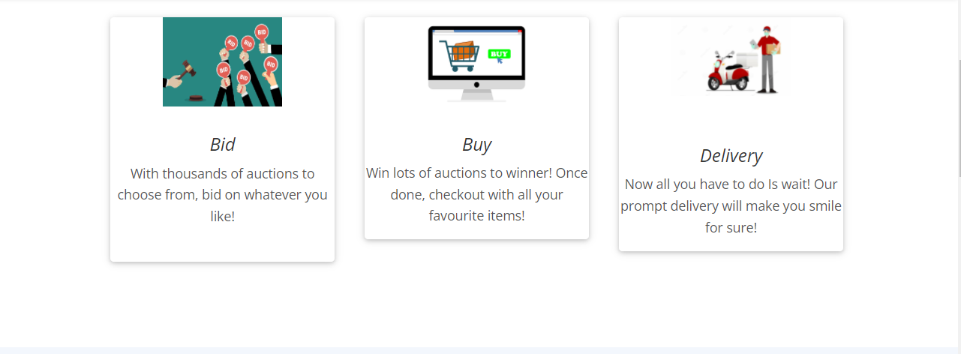 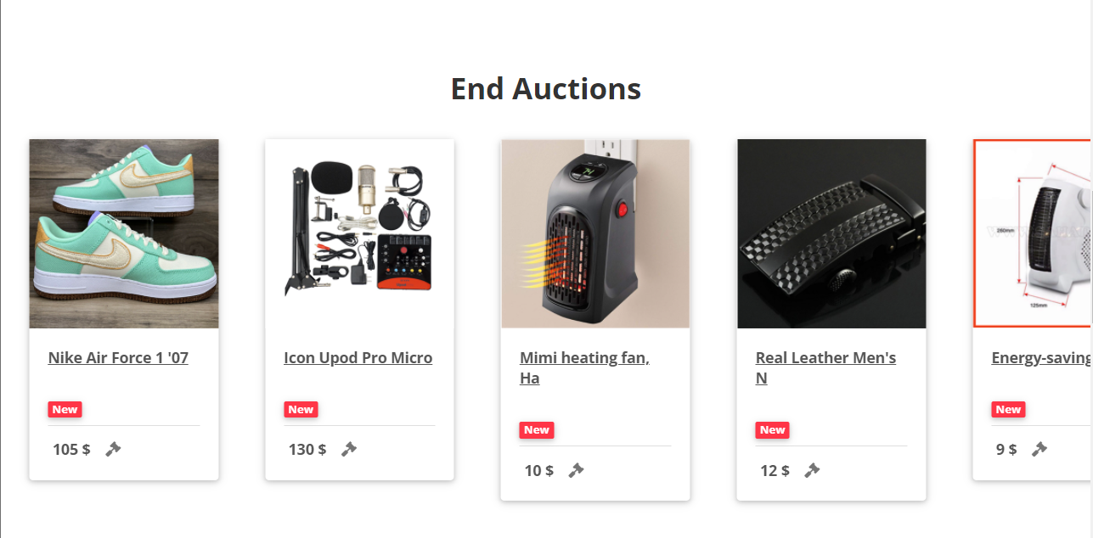 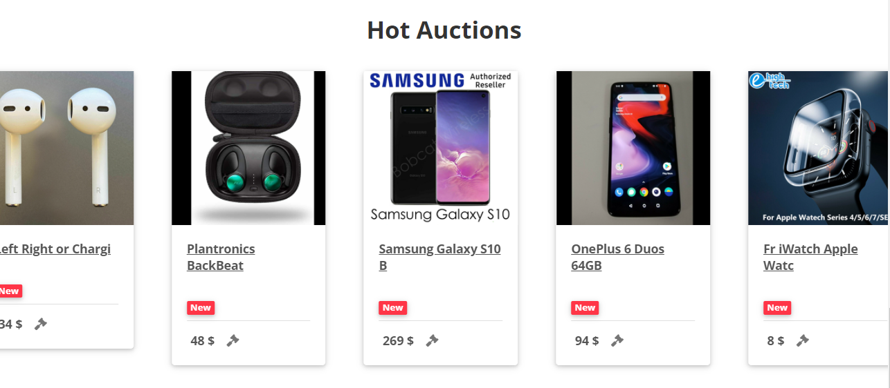

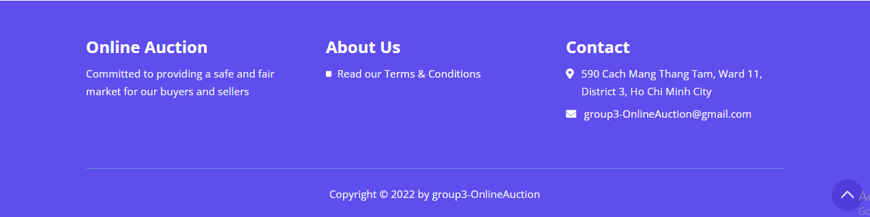

|  |  |  |  |  |  |  |
| --- | --- | --- | --- | --- | --- | --- |
| **No** | **Name** | **Type** | **Validation** | **Event** | **Description** | **Status** |
| 1 | Navigation Bar | Hyperlink |  | Click | Choose and go to pages | Enable |
| 2 | Log In / Register | Button |  | Click | Click to go to Log in/ Register page | Enable |
| 3 | Auction | Hyperlink |  | Click | Filter Auction Page | Enable |
| 4 | Register | Hyperlink |  | Click | Click to go to Detail Register Page | Enable |

## Register page

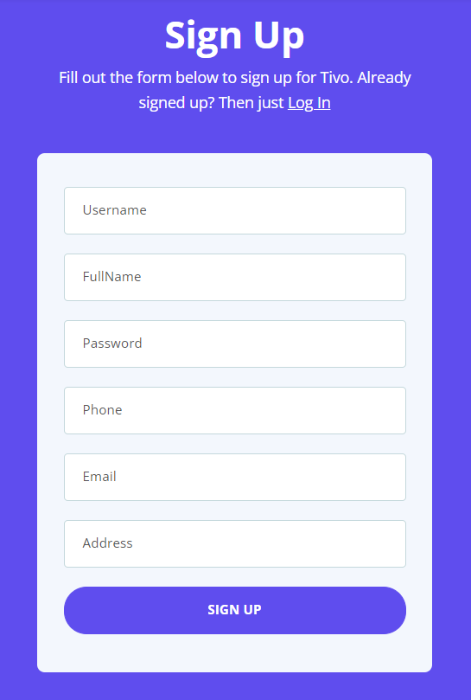

|  |  |  |  |  |  |  |
| --- | --- | --- | --- | --- | --- | --- |
| **No** | **Name** | **Type** | **Validation** | **Event** | **Description** | **Status** |
| 1 | Username | Input | Required | Focus | Input Username | Enable |
| 2 | Password | Input | Required | Focus | Input Password | Enable |
| 3 | Email | Input | Required | Focus | Input Email | Enable |
| 4 | Address | Input | Required | Focus | Input Address | Enable |
| 5 | Phone | Input | Required | Focus | Input Phone |  |
| 6 | Fullname | Input | Required | Focus | Input Full name | Enable |
| 8 | Register | Button |  | Click | Create new user, record into database | Enable |
| 9 | Log In | Hyperlink |  | click | Click back to Log In Page | Enable |

## Login Page

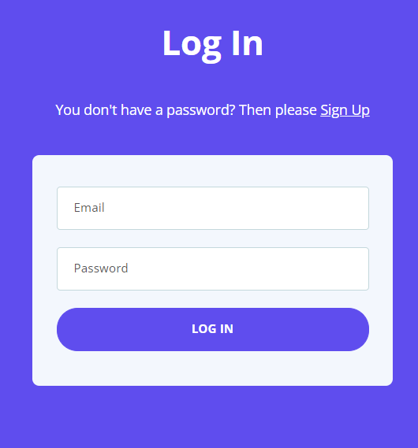

|  |  |  |  |  |  |  |
| --- | --- | --- | --- | --- | --- | --- |
| **No** | **Name** | **Type** | **Validation** | **Event** | **Description** | **Status** |
| 1 | Email | Input | Required | Focus | Input Email | Enable |
| 2 | Password | Input | Required | Focus | Input Password | Enable |
| 3 | Login | Button |  | Click | Log in | Enable |
| 4 | Register | Hyperlink |  | click | Click to go to Register Page | Enable |

## List Auction page

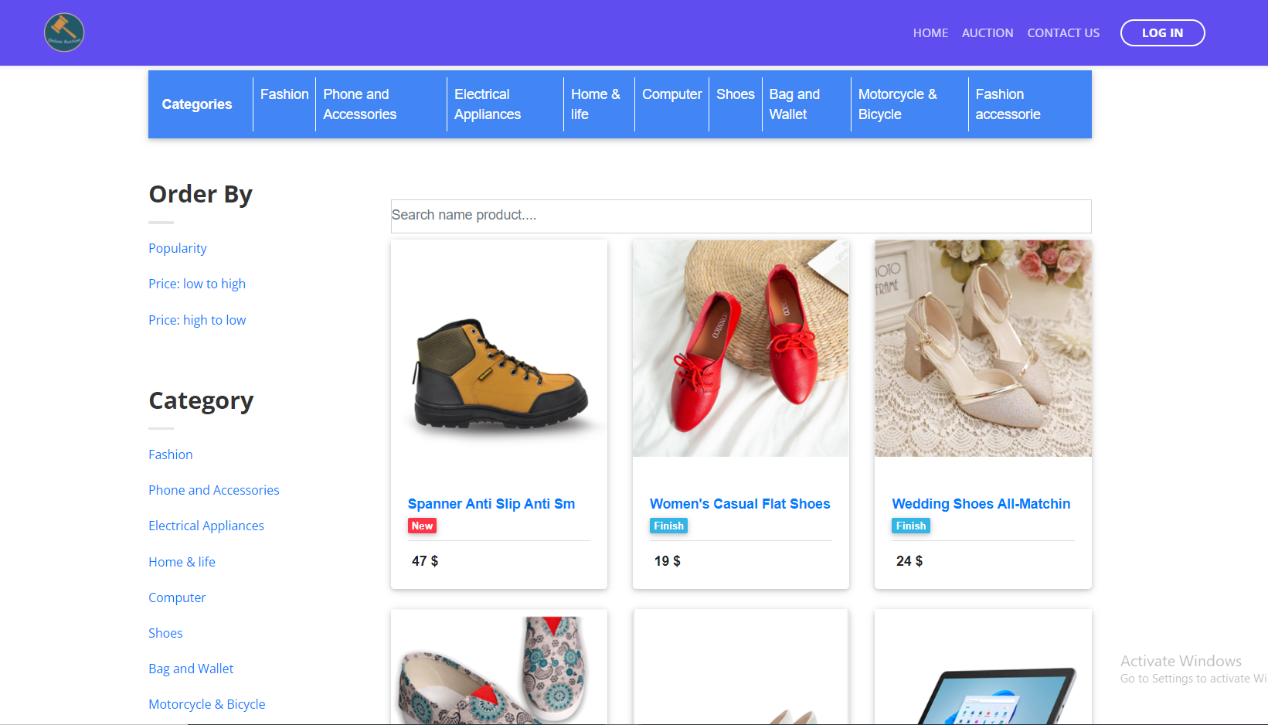

|  |  |  |  |  |  |  |
| --- | --- | --- | --- | --- | --- | --- |
| **No** | **Name** | **Type** | **Validation** | **Event** | **Description** | **Status** |
| 1 | Sort | Hyperlink |  | Click | Sort Auction Page with price | Enable |
| 2 | Search | Input |  | Click | Click submit search title Auction | Enable |
| 3 | Category | Hyperlink |  | Click | Filter Auction Page with category name | Enable |
| 4 | View Detail Recipe | Hyperlink |  | Click | Click to go to Detail Auction Page | Enable |
| 5 | Paginator | Hyperlink |  | Click | Change page in Auction page | Enable |

## Auction_detail

## 

## 

|  |  |  |  |  |  |  |
| --- | --- | --- | --- | --- | --- | --- |
| **No** | **Name** | **Type** | **Validation** | **Event** | **Description** | **Status** |
| 1 | Login to Bid | Button |  | Click | Go to Login Page | Enable |
| 2 | Bid | Button |  | Click | Go to Modal to enter bid | Enable |
| 3 | Review to Seller | Button |  | Click | Go to Create Review to Seller Page | Enable |
| 4 | Email Seller | Hyperlink |  | Click | Go to Profile Seller Page | Enable |
| 5 | Report | Button |  |  | Go to Create Report to Seller Page |  |
| 6 | Pay Now | Button |  | Click | Click to Check out | Enable |

## Create Bid Auction

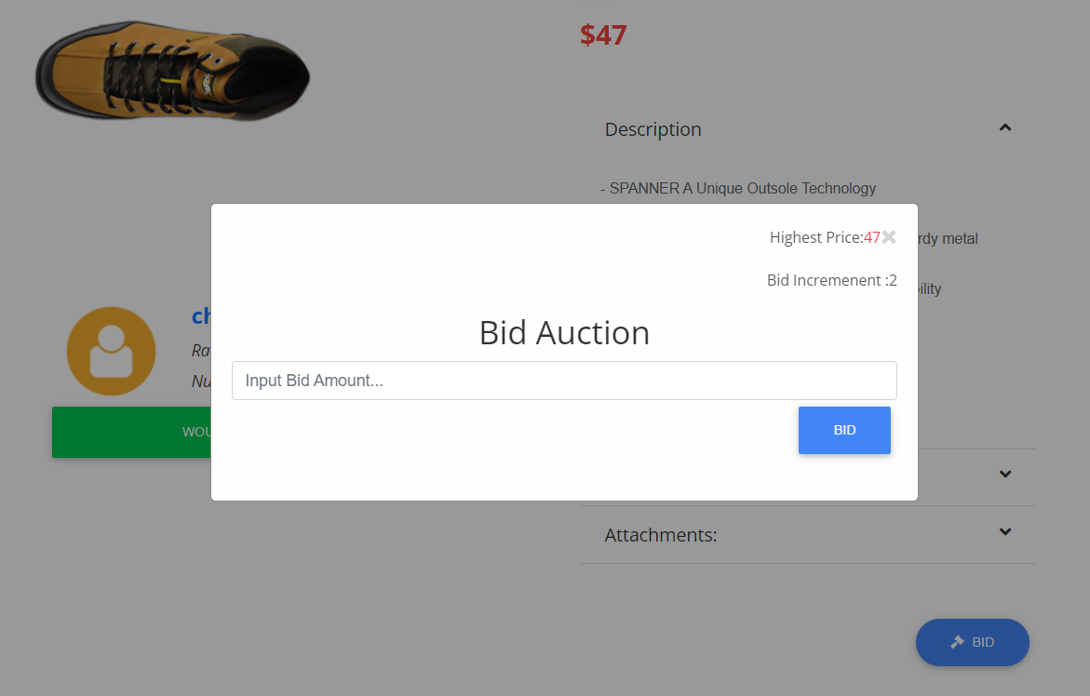

|  |  |  |  |  |  |  |
| --- | --- | --- | --- | --- | --- | --- |
| **No** | **Name** | **Type** | **Validation** | **Event** | **Description** | **Status** |
| 1 | Bid Amount | Input | Required | Focus | Input bid amount | Enable |
| 2 | Bid | Button |  | Click | Submit Bid to Admin | Enable |

## Review Page

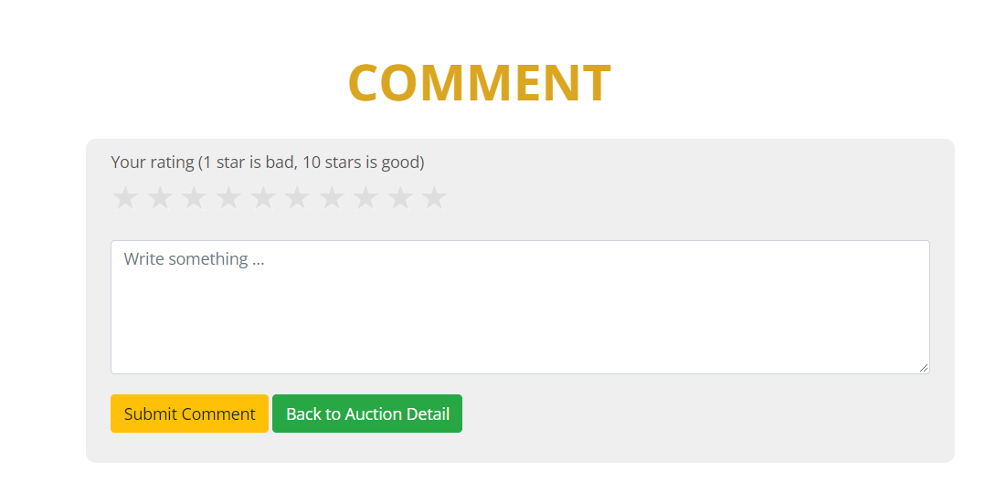

|  |  |  |  |  |  |  |
| --- | --- | --- | --- | --- | --- | --- |
| **No** | **Name** | **Type** | **Validation** | **Event** | **Description** | **Status** |
| 1 | Star | Button | Required | Click | Click for rating score | Enable |
| 2 | Comment | Input | Required | Focus | Input comment | Enable |
| 3 | Submit | Button |  | Click | Submit Rating to Admin |  |

## 10.Report Page

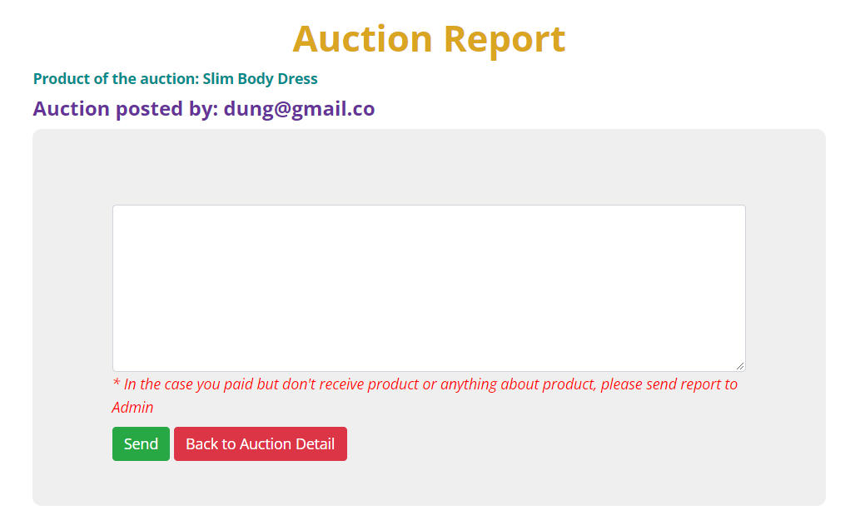

|  |  |  |  |  |  |  |
| --- | --- | --- | --- | --- | --- | --- |
| **No** | **Name** | **Type** | **Validation** | **Event** | **Description** | **Status** |
| 1 | Content | Input | Required | Focus | Input content report | Enable |
| 2 | Submit | Button |  | Click | Submit Report to Admin | Enable |
| 3 | Email | Hyperlink |  | Click | Go to Profile of Seller | Enable |

## 11. Profile Seller page

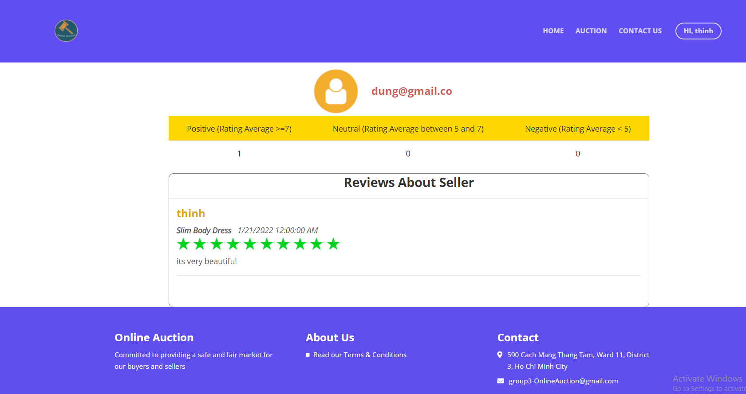

## 12. Profile User Page

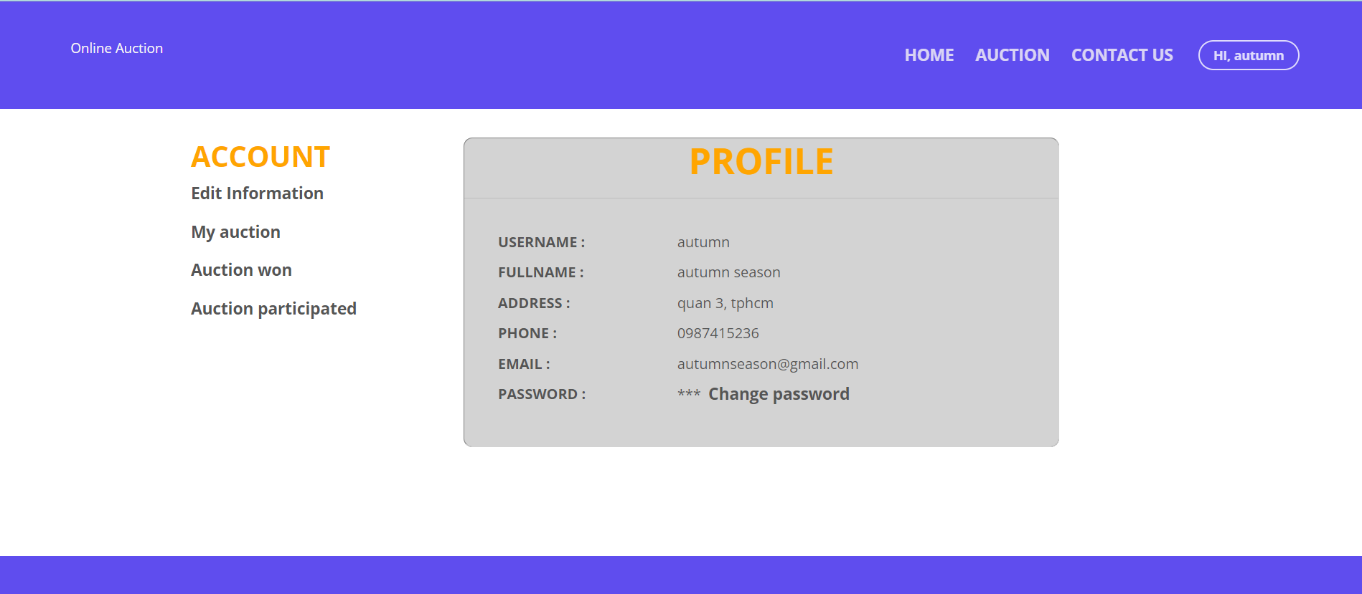

|  |  |  |  |  |  |  |
| --- | --- | --- | --- | --- | --- | --- |
| **No** | **Name** | **Type** | **Validation** | **Event** | **Description** | **Status** |
| 1 | Edit Information | Hyperlink |  | Click | Go to edit Account Page | Enable |
| 2 | Edit | Button |  | Click | Go to edit Account Page | Enable |
| 3 | Change Password | Hyperlink |  | Click | Go to edit Password Page | Enable |
| 4 | My Auction | Hyperlink |  | Click | Go to My Auction Page | Enable |
| 5 | Auction Won | Hyperlink |  | Click | Go to edit Account Page | Enable |
|  | Auction participated | Hyperlink |  | Click | Go to edit Account Page | Enable |

## 13. My Auction Page

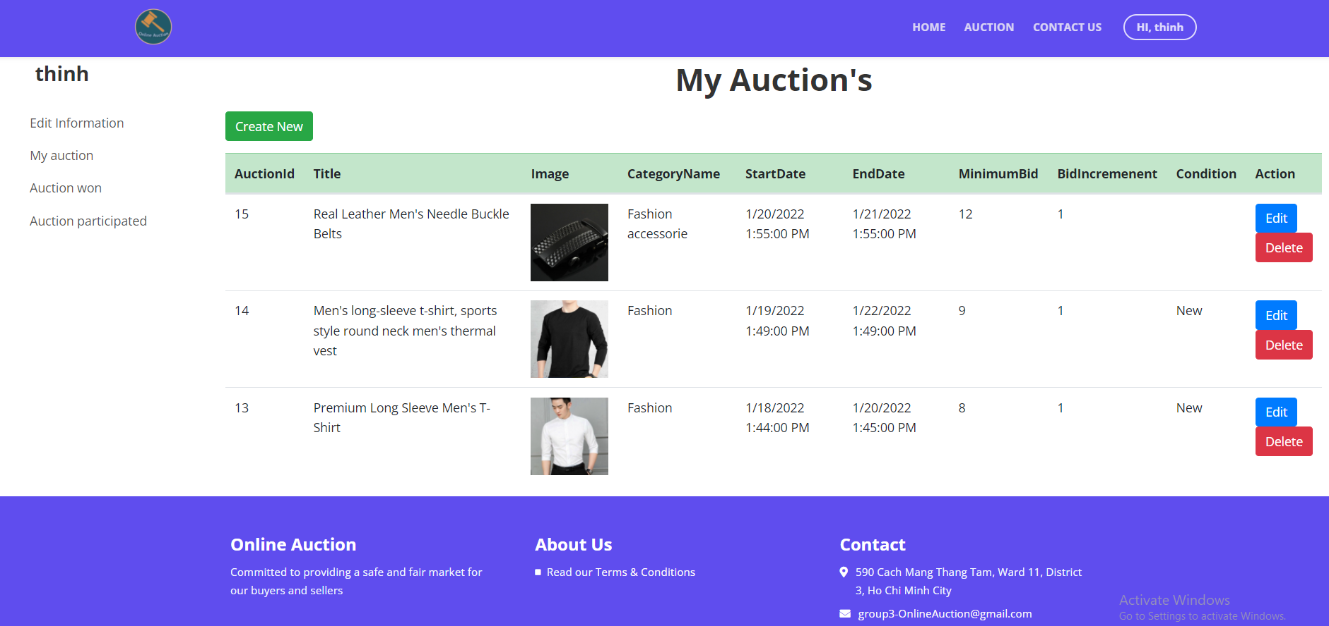

|  |  |  |  |  |  |  |
| --- | --- | --- | --- | --- | --- | --- |
| **No** | **Name** | **Type** | **Validation** | **Event** | **Description** | **Status** |
| 1 | Title | Hyperlink |  | Click | Go to Detail Auction Page | Enable |
| 2 | Create | Button |  | Click | Go to Create Auction Page | Enable |
| 3 | Edit | Button |  | Click | Go to Edit Auction Page | Enable |
| 4 | Delete | Button |  | Click | Delete Auction | Enable |

## 14. Create Auction Page

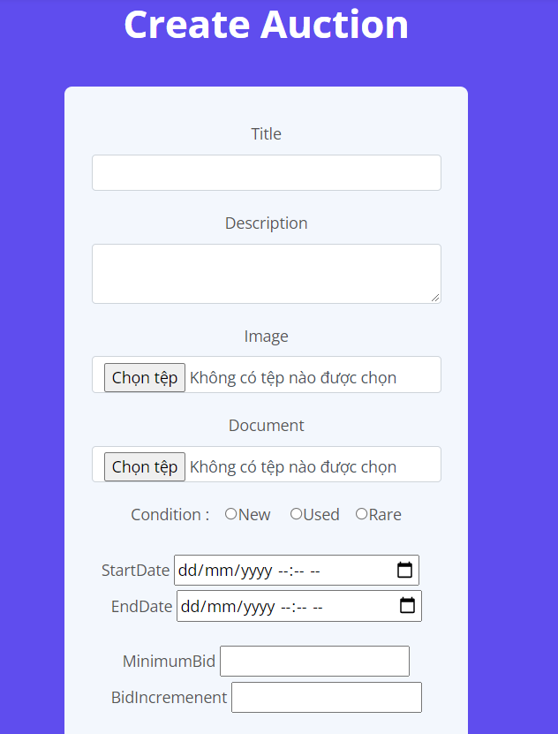 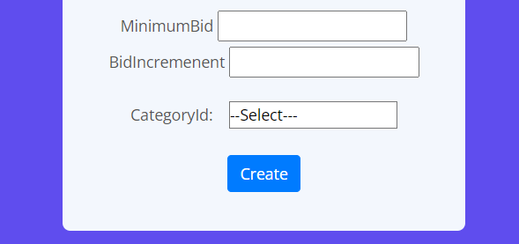

|  |  |  |  |  |  |  |
| --- | --- | --- | --- | --- | --- | --- |
| **No** | **Name** | **Type** | **Validation** | **Event** | **Description** | **Status** |
| 1 | Ttile | Textbox | - Not null | Focus | Input title of Auction | Enable |
| 2 | Description | TextArea | - Not null | Focus | Input title of Auction | Enable |
| 3 | Image | file | - Not null | Click | Upload image of Auction | Enable |
| 4 | Document | file | -Not null | Click | Upload document of Auction | Enable |
| 5 | Condition | Radio | -Not null | Click | Click to select condition | Enable |
| 6 | StartDate | Textbox | -Not null | Focus | Input start date of Auction | Enable |
| 7 | EndDate | Textbox | -Not null | Focus | Input end date of Auction | Enable |
| 8 | MinimumBid | number | -Not null | Focus | Input starting price of Auction | Enable |
| 9 | BidIncremenent | number | -Not null | Focus | Input Incremenent of Bid | Enable |
| 10 | CategoryId | Select | -Not null | Click | Click to select Category | Enable |
| 11 | Create | Submit |  | Click | Click to update database | Enable |

## 15. Edit Auction Page

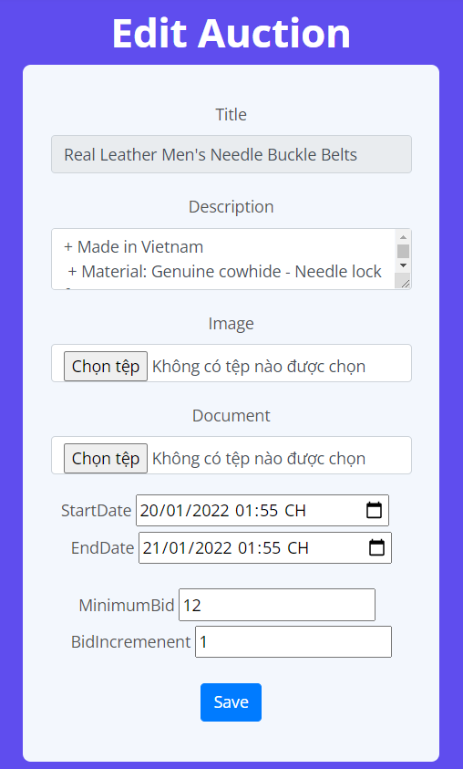

|  |  |  |  |  |  |  |
| --- | --- | --- | --- | --- | --- | --- |
| **No** | **Name** | **Type** | **Validation** | **Event** | **Description** | **Status** |
| 1 | Description | TextArea |  | Focus | Input title of Auction | Enable |
| 2 | Image | file |  | Click | Upload image of Auction | Enable |
| 3 | Document | file |  | Click | Upload document of Auction | Enable |
| 4 | StartDate | Textbox |  | Focus | Input start date of Auction | Enable |
| 5 | EndDate | Textbox |  | Focus | Input end date of Auction | Enable |
| 6 | BidIncremenent | number |  | Focus | Input Incremenent of Bid | Enable |
| 7 | Save | Submit |  | Click | Click to update database |  |

## 18. Dashboard Admin

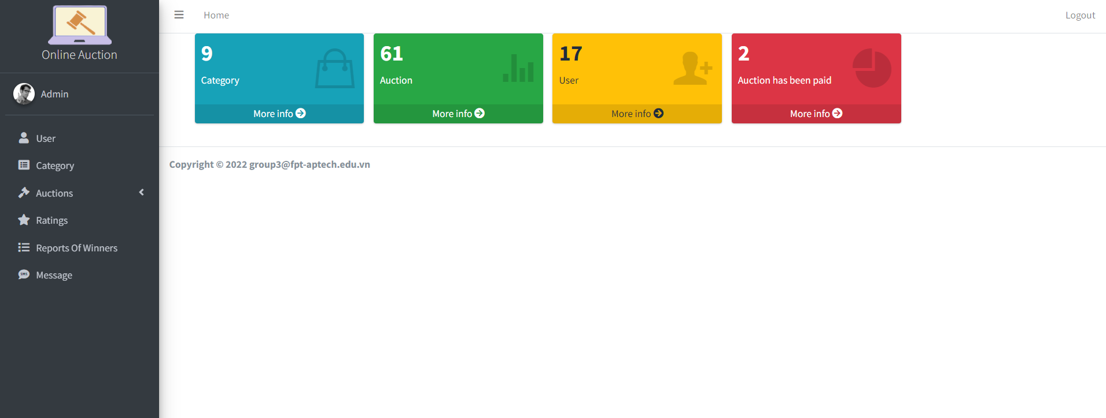

## 19. Management Category

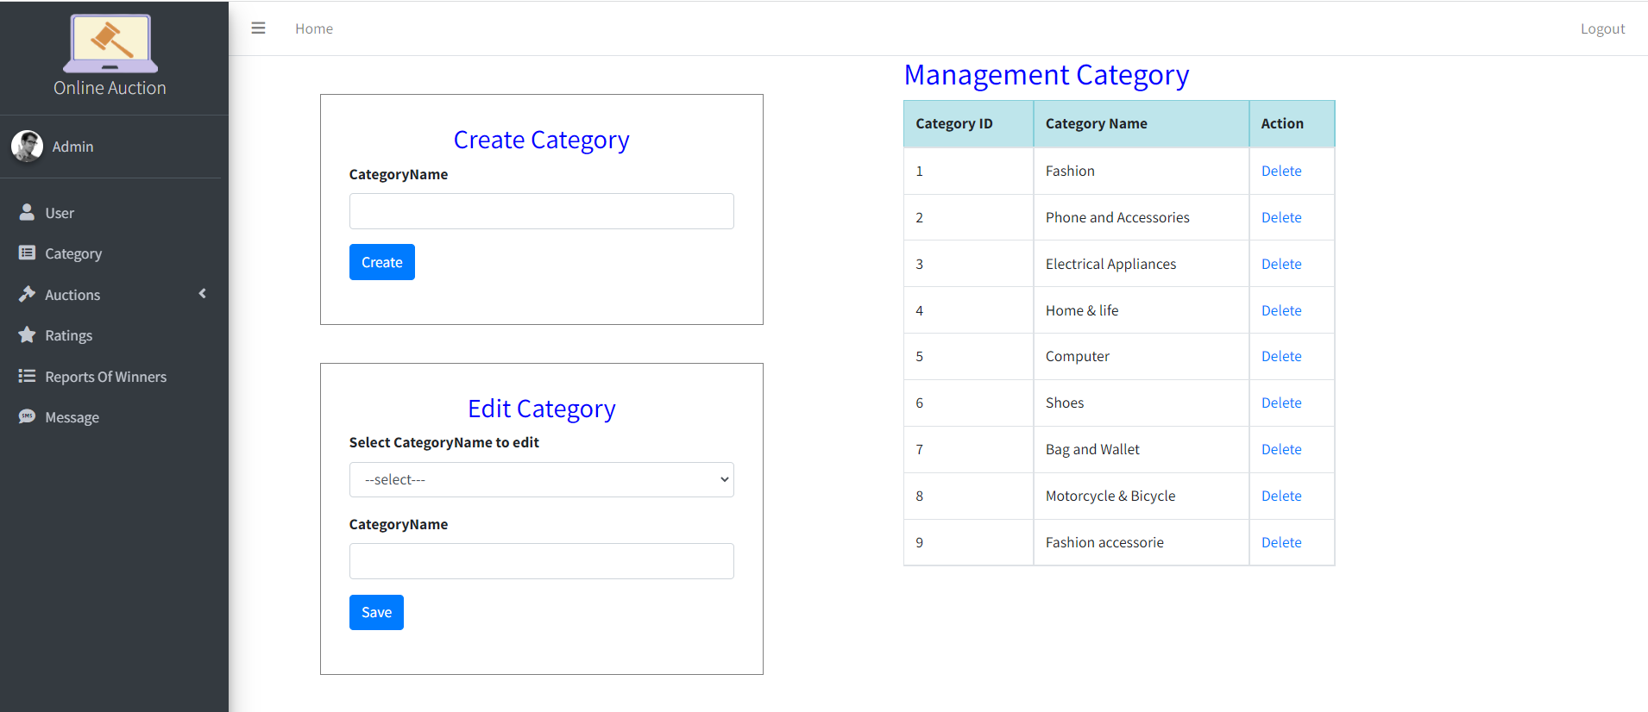

|  |  |  |  |  |  |  |
| --- | --- | --- | --- | --- | --- | --- |
| **No** | **Name** | **Type** | **Validation** | **Event** | **Description** | **Status** |
| 1 | Category List | Table |  |  | List of categories | Enable |
| 2 | Category Name | Input | required | Focus | Input Category Name | Enable |
| 3 | Create | Click |  | Click | Click to update database | Enable |
| 4 | Delete | Hyperlink |  | Click | Process to delete category | Enable |
| 5 | CategoryName | Select |  | Click | Click to select Category to edit | Enable |
| 6 | Edit | Button |  | Click | Click to update database | Enable |

## 20.Admin Auction List

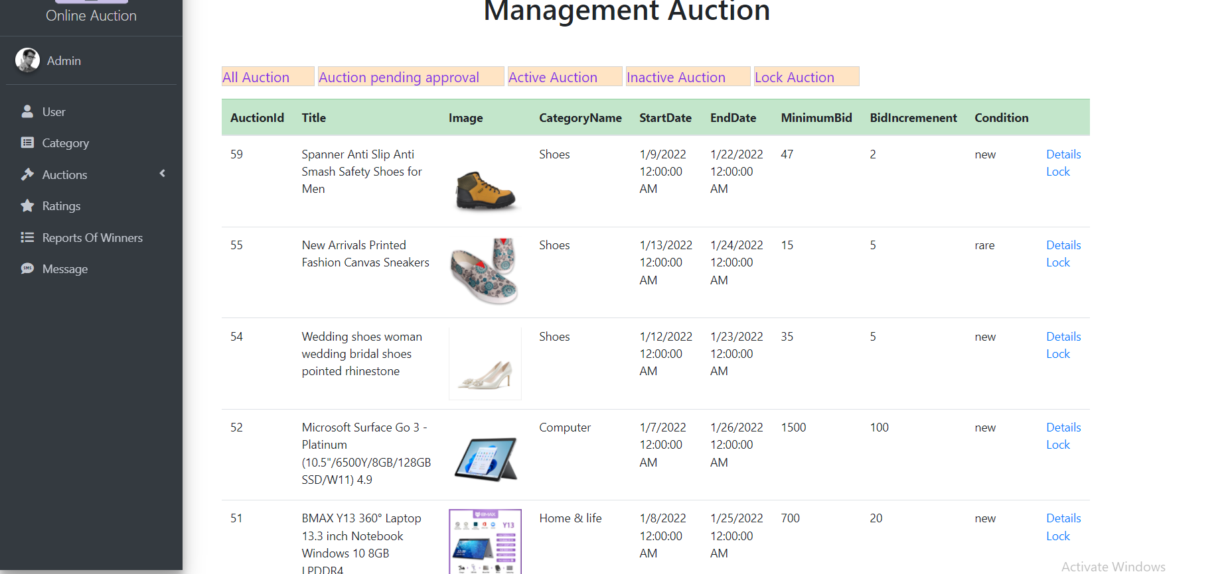

|  |  |  |  |  |  |  |
| --- | --- | --- | --- | --- | --- | --- |
| **No** | **Name** | **Type** | **Validation** | **Event** | **Description** | **Status** |
| 1 | All Auction | Hyperlink |  | Click | List of All Auctions | Enable |
| 2 | Auction pending approval | Hyperlink |  | Click | Filter Auction not approved yet | Enable |
| 3 | Active Auction | Hyperlink |  | Click | Filter Auction is active | Enable |
| 4 | Inactive Auction | Hyperlink |  | Click | Filter Auction finished | Enable |
| 5 | Lock Auction | Hyperlink |  | Click | Filter Auction lock | Enable |
| 6 | Details | Hyperlink |  | Click | Go to Details Auction Page | Enable |
| 7 | Approval | Hyperlink |  | Click | Click approval Auction | Enable |
| 8 | Lock | Hyperlink |  | Click | Click lock Auction | Enable |

## 20. Admin User List

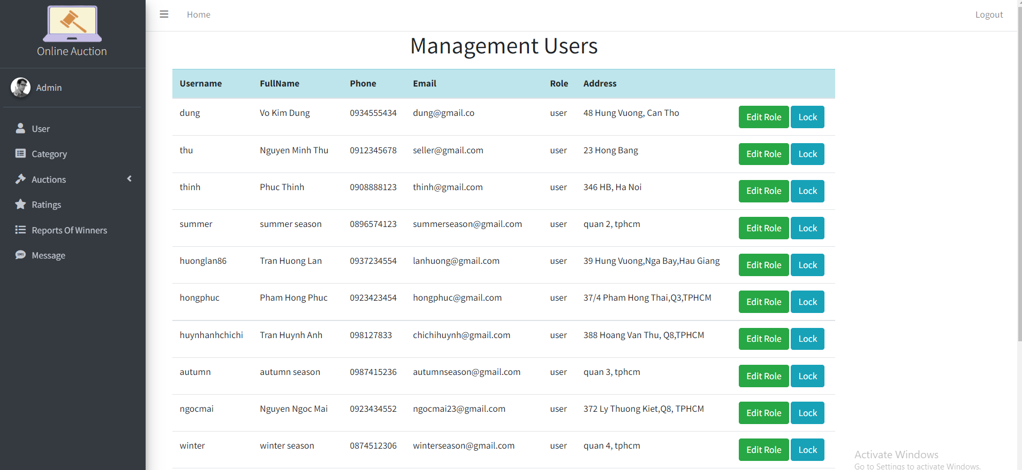

|  |  |  |  |  |  |  |
| --- | --- | --- | --- | --- | --- | --- |
| **No** | **Name** | **Type** | **Validation** | **Event** | **Description** | **Status** |
| 1 | Navigation Side Bar | Hyperlink |  | Click | Choose and goto page | Enable |
| 2 | Edit Role | Button |  | Click | Click to change role from use to admin | Enable |
| 3 | Lock | Button |  | Click | Click to lock Account user | Enable |
| 4 | List of locked accounts | Hyperlink |  | Click | Go to LockAccount Page | Enable |
| 5 | List of Admin Accounts | Hyperlink |  | Click | Go to AdminAccount Page | Enable |

## 21. Admin list News

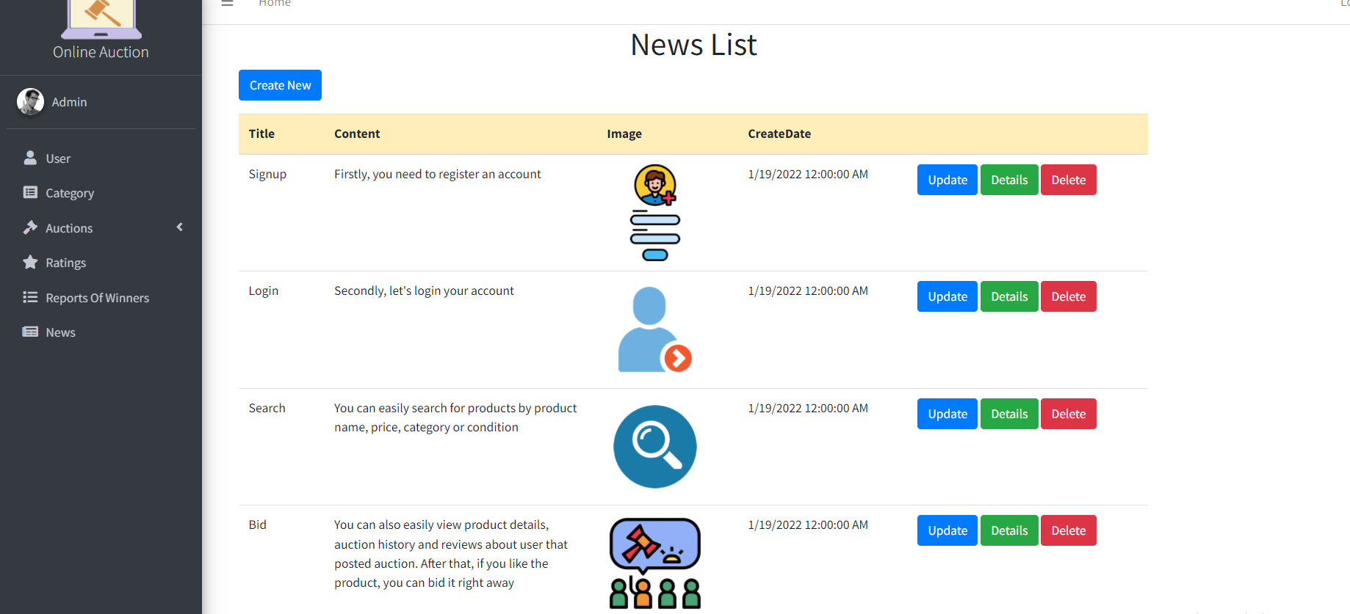

|  |  |  |  |  |  |  |
| --- | --- | --- | --- | --- | --- | --- |
| **No** | **Name** | **Type** | **Validation** | **Event** | **Description** | **Status** |
| 1 | Navigation Side Bar | Hyperlink |  | Click | Choose and click to go to pages | Enable |
| 2 | Create | Button |  | Click | Click to go to Ceate News | Enable |
| 3 | Edit | Button |  | Click | Click to go to Update News | Enable |
| 4 | Delete | Button |  | Click | Click to delete News | Enable |

## 22. Admin create News

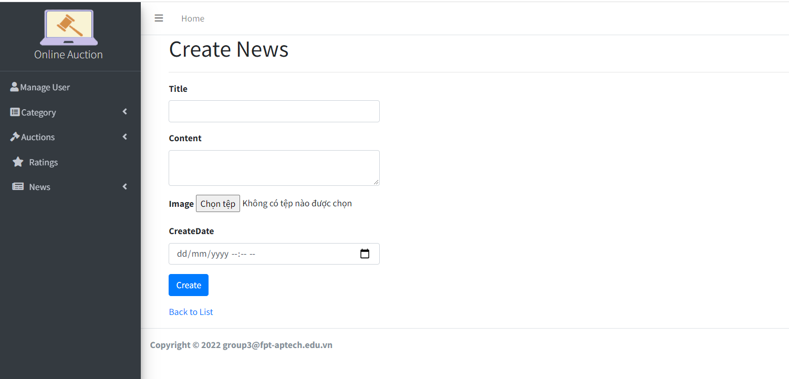

|  |  |  |  |  |  |  |
| --- | --- | --- | --- | --- | --- | --- |
| **No** | **Name** | **Type** | **Validation** | **Event** | **Description** | **Status** |
| 1 | Navigation Side Bar | Hyperlink |  | Click | Choose and click to go to pages | Enable |
| 2 | Title | Textbox |  | Focus | Input title News | Enable |
| 3 | Content | Button |  | Focus | Input content News | Enable |
| 4 | Image | file |  | Focus | Click to upload Image | Enable |
| 5 | Create | Button |  | Click | Click to update database | Enable |

## 23. Admin update News

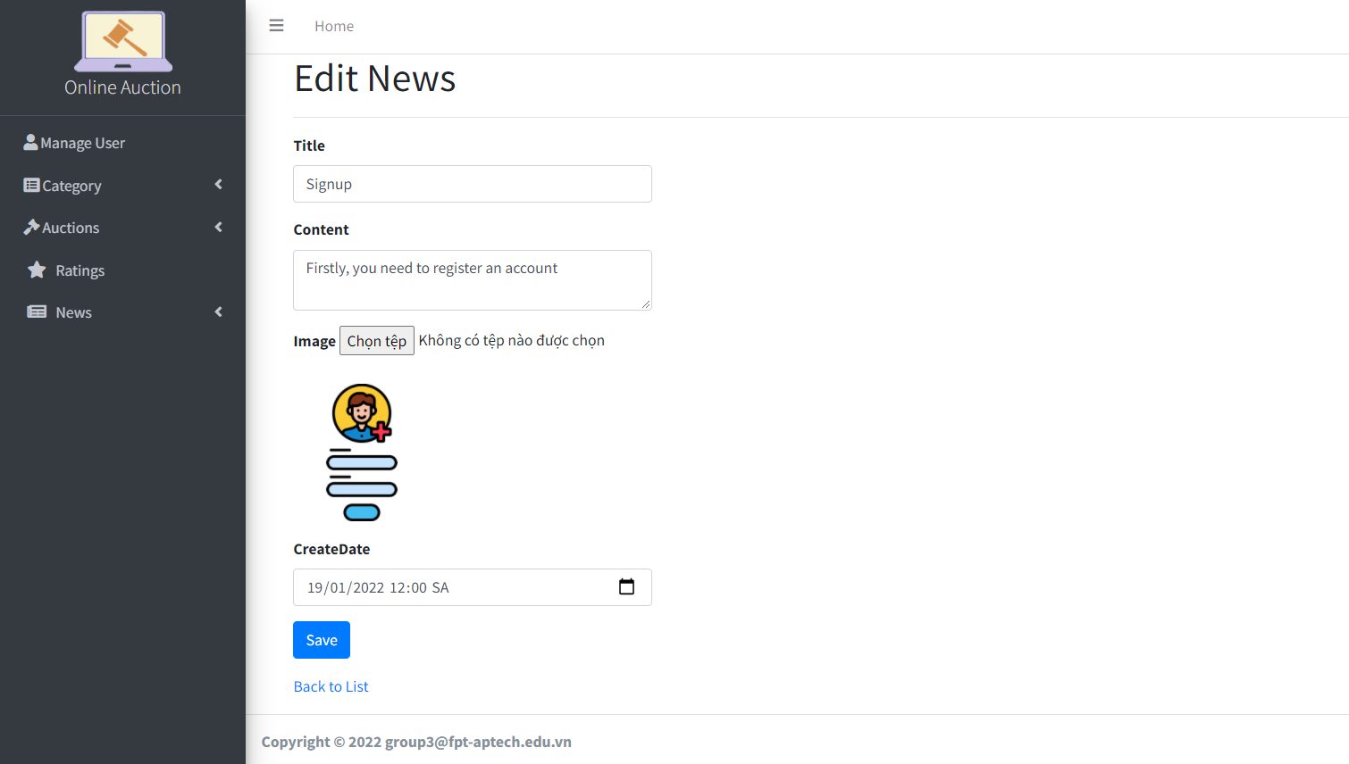

|  |  |  |  |  |  |  |
| --- | --- | --- | --- | --- | --- | --- |
| **No** | **Name** | **Type** | **Validation** | **Event** | **Description** | **Status** |
| 1 | Navigation Side Bar | Hyperlink |  | Click | Choose and click to go to pages | Enable |
| 2 | Title | Textbox |  | Focus | Input title News | Enable |
| 3 | Content | Button |  | Focus | Input content News | Enable |
| 4 | Image | file |  | Focus | Click to upload Image | Enable |
| 5 | Create | Button |  | Click | Click to update database | Enable |

## 24. Admin list Rating

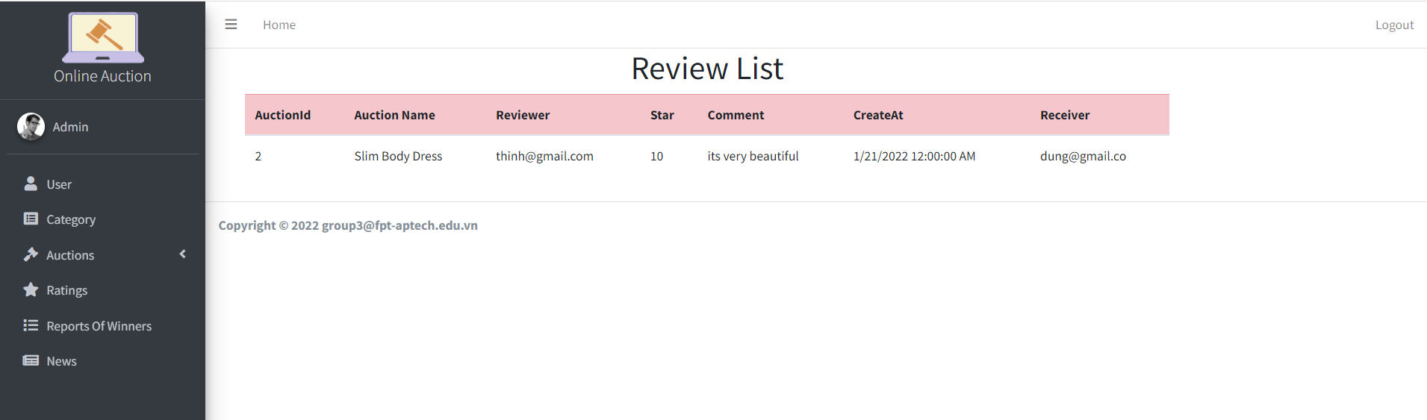

|  |  |  |  |  |  |  |
| --- | --- | --- | --- | --- | --- | --- |
| **No.** | **Name** | **Type** | **Validation** | **Event** | **Description** | **Status** |
| 1 | Navigation Side Bar | Hyperlink |  | Click | Choose and click to go to pages | Enable |
| 2 | Dropdown Menu | Button |  | Click | Click to go to Create/Update | Enable |
| 3 | Search | button |  | Click | Click to search category or name book | Enable |
| 4 | Action | Hyperlink |  | Click | Click to edit/detail/delete book information | Enable |
| 5 | Pagination | Button |  | Click | Click to pagination | Enable |

## 25. Admin list Report

